Minimizing the Maximum Delay for Reaching Consensus in Quorum-Based Mutual Exclusion Schemes
Tatsuhiro Tsuchiya, Masatoshi Yamaguchi, and Tohru Kikuno
IEEE Transactions on parallel and distributed systems, VOL. 10, NO. 4, Apr. 1999, pp. 337-345
Abstract
In this paper, authors propose a polynomial-time algorithm for finding max-delay optimal coteries and, then, modify the algorithm so as to reduce the mean-delay of generated coteries. Unlike the previous algorithms, the proposed algorithms can be applied to systems with arbitrary topology.
- Introduction
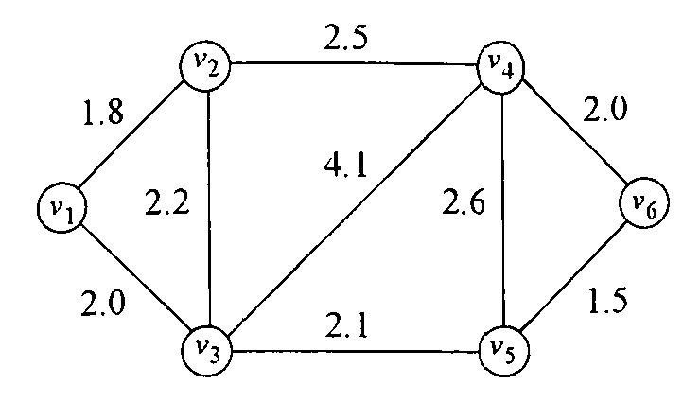
- Preliminaries
dist (v_{i}, v_{j}) = dist (v_{j}, v_{i}) = length of the shortest path between v_{i} & v_{j}.
delay (v_{i}, V’) = max_{v∈V’}{dist (v_{i}, v)}, V’ is a nonempty subset of V.
Delay (v_{i}, C) = min_{Q∈C}{max_{v∈Q}{dist (v_{i}, v)}} = min_{Q∈C}{delay (v_{i}, Q)}
max-delay (C) = max_{v∈V}{Delay(v, C)}
mean-delay (C) = (∑_{v∈V}Delay (v, C))/|V|
A coterie C is said to be a Max-delay optimal coterie iff max-delay (C) = min_{C’∈UC}{max-delay (C’)}, UC is the set of all coteries.
- Finding Max-Delay Optimal Coteries
e.g.
Consider the system shown in Fig. above. First, candidates for min are sorted as follows:
1.5, 1.8, 2.0, 2.1, 2.2, 2.5, 2.6, 3.6, 4.1, 4.3, 4.5, 5.6
The value of min is calculated to be 3.6, D_{i} are as follows:
D₁ = {v₁, v₂, v₃}
D₂ = {v₁, v₂, v₃, v₄}
D₃ = {v₁, v₂, v₃, v₅, v₆}
D₄ = {v₂, v₄, v₅, v₆}
D₅ = {v₃, v₄, v₅, v₆}
D₆ = {v₃, v₄, v₅, v₆}
In this case, the max-delay optimal coterie is
{{v₁, v₂, v₃}, {v₂, v₄, v₅, v₆}, {v₃, v₄, v₅, v₆}}
- Extension for Reducing Mean-Delay
- Evaluation
- Conclusions

Created by : Kwo-Tsung Tseng
Date : Jun. 30, 1999

